2a. CLASSIFICATION USING SVM ON LOAD_IRIS DATASET

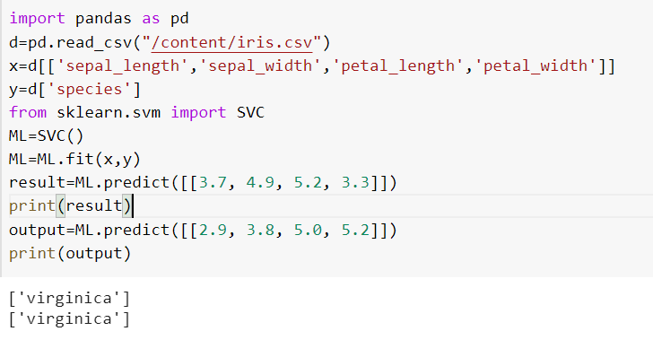

2b. CLASSIFICATION USING SVM ON HEART DATASET

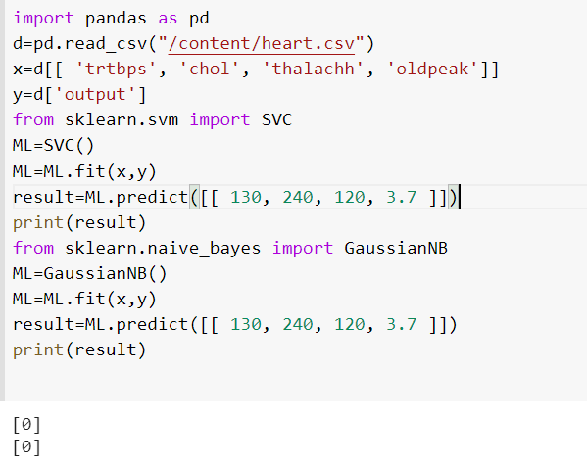

2c. CLASSIFICATION USING SVM ON LOAD_WINE DATASET

